Python Variable

A Python variable is a name that is used to store data in the computer's memory, so you can use it later in your program.

In simple words: A variable is like a label for a value.

Example:

city = "Mumbai"
age = 25
is_raining = False

- city → holds the text "Mumbai"
- age → holds the number 25
- is_raining → holds the Boolean value False

General Rules for Naming Variables
- Must start with a letter or an underscore (_)
  - Valid: speed, _count
  - Invalid: 1score, @rate
- Can contain letters (a-z, A-Z), digits (0-9), and underscores (_)
  - Valid: marks_2025, price_in_rupees
  - Invalid: total-amount, class*fees
- Cannot use spaces
  - Use underscores or camelCase instead
  - Valid : totalMarks or total_marks
  - Invalid : total marks

- Cannot be a keyword or reserved word in that language
  - e.g., if, while, class, for, def, return are reserved in most languages
- Case-sensitive
  - amount, Amount, and AMOUNT are all different variables

Types of Comments in Python

1. Single-line Comment
Starts with # and lasts until the end of the line.
# This is a single-line comment
speed = 90 # Speed of the car in km/h

2. Multi-line Comment (Technically not true multiline but commonly used)
Python doesn't have a dedicated multi-line comment syntax, but you can use a triple-quoted string (''' or """) that is not assigned to any variable.

'''
This is a multi-line comment.
Used to describe sections of code.
It is not stored or executed.
'''

Python Data Types
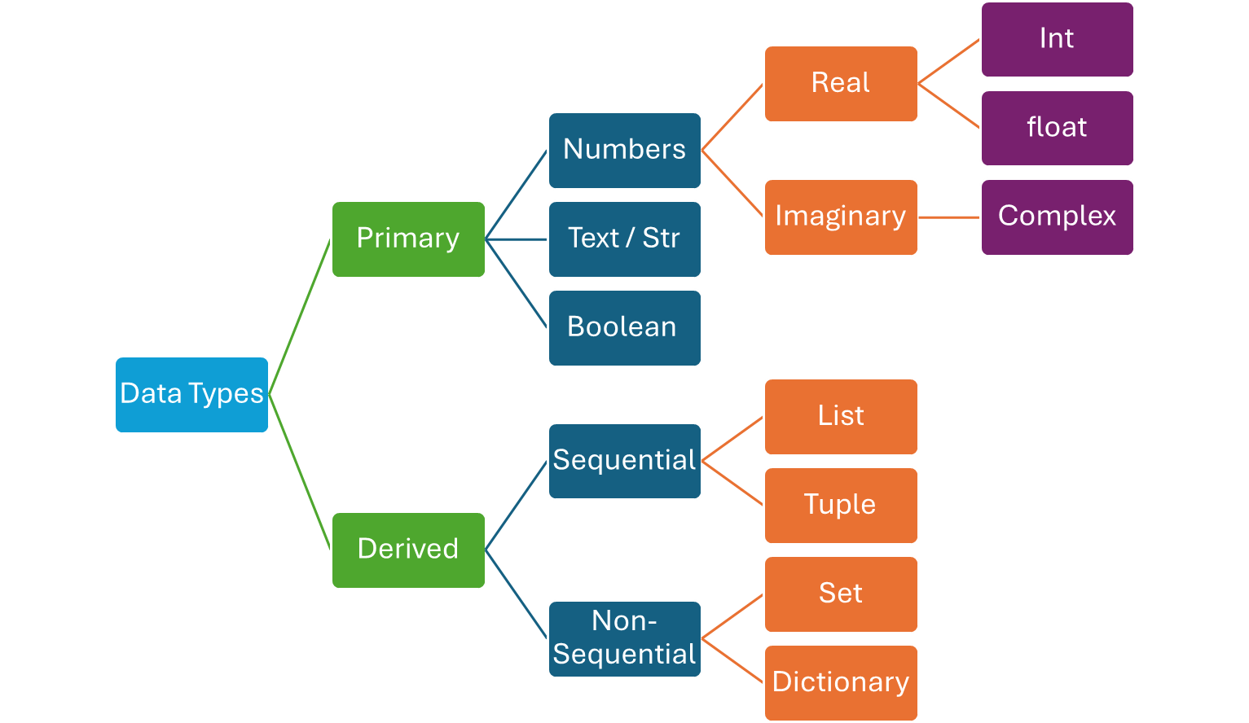

int (Integer)
Represents whole number
apples = 5
print(apples)

Output: 5

float (Floating point)
Decimal value (value with points)
milk_liters = 1.5
print(milk_liters)
Output: 1.5

str (Text/String)
city = "Mumbai"
print(city)

Output: Mumbai

List
Collection of items, allows duplicates and is ordered and mutable (changable).
groceries = ["rice", "oil", "salt"]
print(groceries)

Output: ['rice', 'oil', 'salt']

tuple
Collection of items, allows duplicates and is ordered and immutable (unchangeable).
coordinates = (19.07, 72.87)
print(coordinates)

Output: (19.07, 72.87)
Explanation: Tuple for geographic coordinates, immutable.

set
unique_brands = {"Nike", "Adidas", "Puma"}
print(unique_brands)

Output: {'Nike', 'Adidas', 'Puma'} (order may vary)
Explanation: Set with unique brand names, unordered and no duplicates.

dict (Dictionary)
student = {"name": "Rahul", "age": 16}
print(student)

Output: {'name': 'Rahul', 'age': 16}
Explanation: Key-value pairs for storing related info.

Practice Questions

Section 1: Variables & Naming Rules
- What is a variable in Python?
- Which of the following is a valid variable name?
a) 1rate
b) _speed
c) total-amount
d) class*
- Can a variable name start with a number in Python?
- Is total marks a valid variable name? If not, why?
- Choose the correct variable names:
a) _value
b) if
c) Amount
d) total$price
- Are these three variables the same or different?
amount, Amount, and AMOUNT
- Which symbol is allowed in a variable name?
a) -
b) *
c) _
d) @

🔹 Section 2: Comments in Python
- How do you write a single-line comment in Python?
- What will happen if you don’t use # before a comment?
- What do triple quotes (''' or """) usually represent in comments?
- Write a single-line comment to describe a variable that stores speed.
- Can Python have real multi-line comments like C or Java?

🔹 Section 3: Python Data Types
- What type of data does the variable age = 21 store?
- Write a Python variable to store the name of a city.
- Which data type will the variable temperature = 36.5 be?
- What is the output of this code?
apples = 5
print(apples)

- Which data type is used to store a group of values that cannot be changed (immutable)?
- Write a Python statement to store coordinates (latitude and longitude).
- Which data type is used to store values in key-value pairs?
- What will be the output of this code?
student = {"name": "Ankit", "age": 18}
print(student)

- Which data type will you use to store unique brand names?
- Is the order of elements in a set always the same?
- Write a variable that holds a string value.

